Persona Wireframe Generator
My GitHub
rana271/PersonaWireFrameGenerator_Hakathon at develop
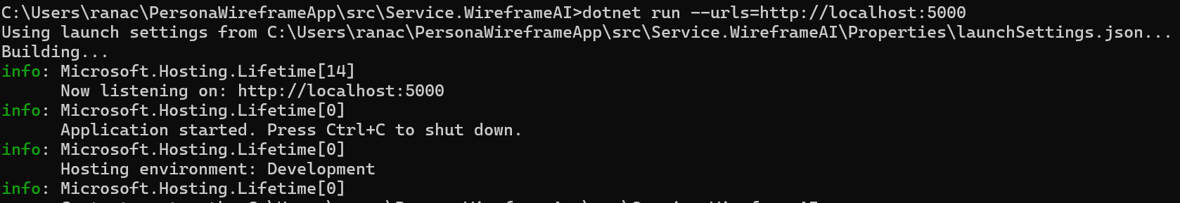
In the above Micro Services Up and Running make sure your Services up and running…
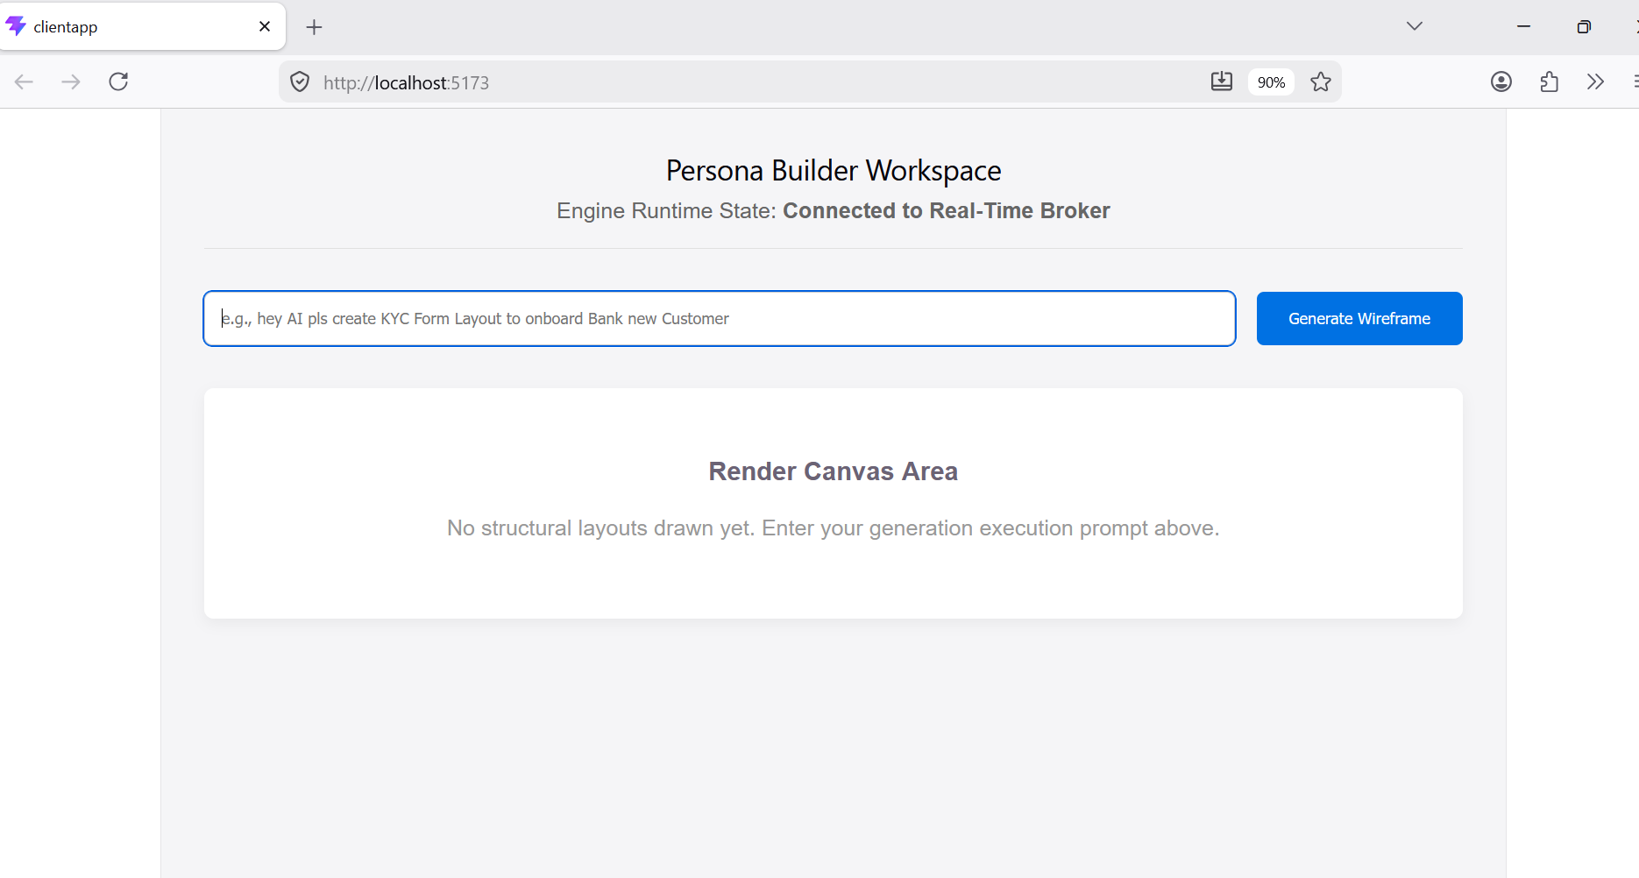
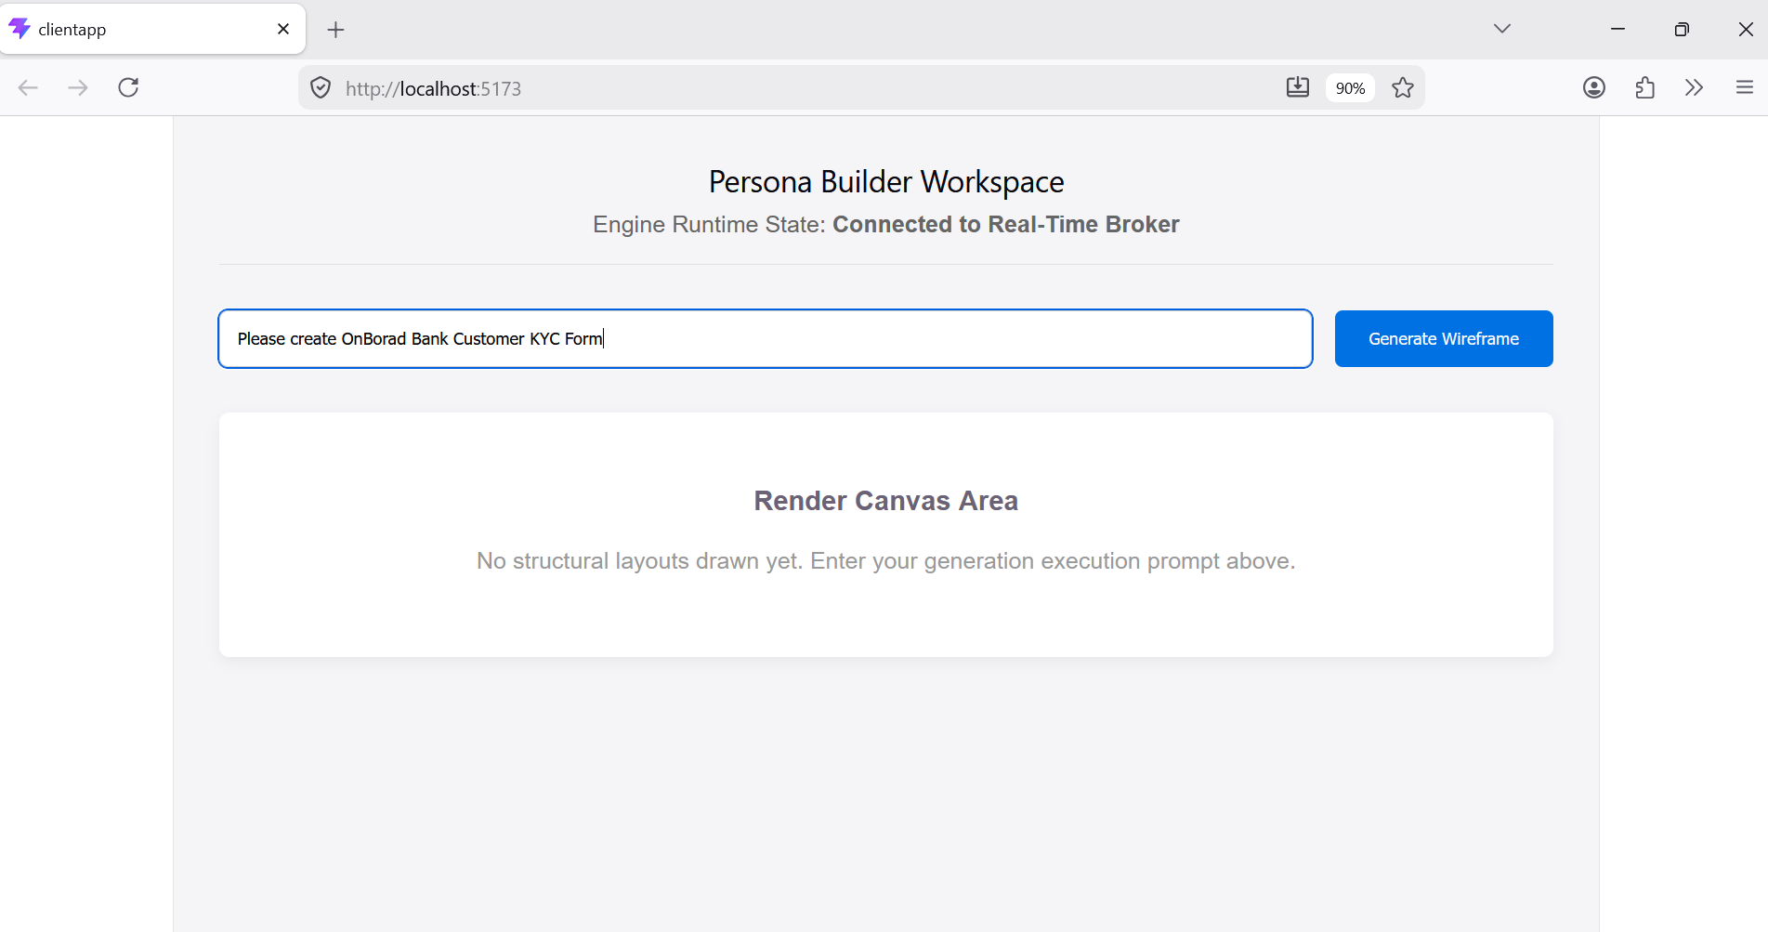

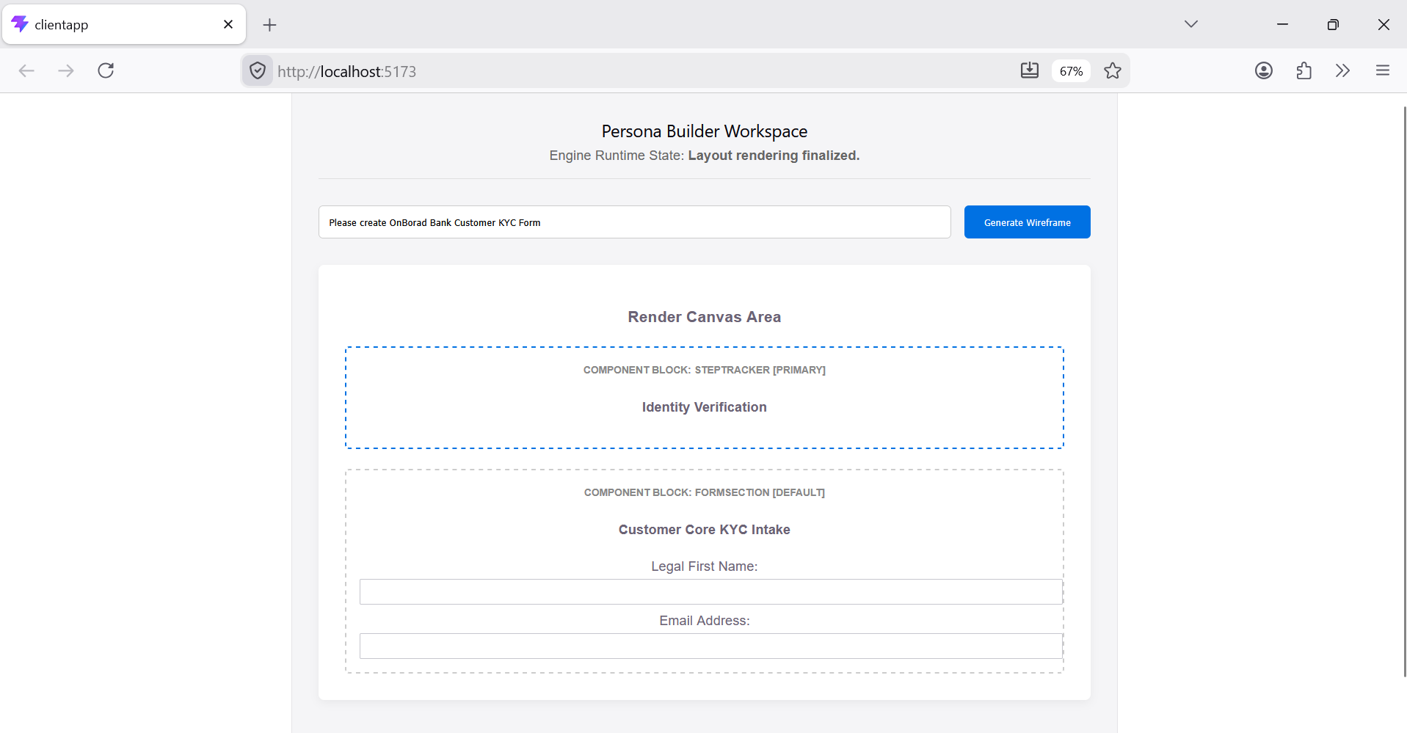
SignalR commmucate as GateWay and Broker
UI

NON Tech user/Client get dashboard like below
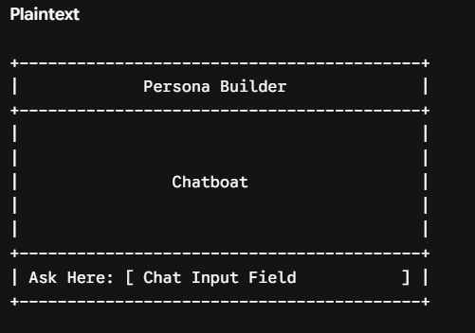
Diagram Description
- Top Header: Labeled "Persona Builder", indicating the active module or workspace.
- Central Area: Main workspace area labeled "Chatboat" (Chatbot), where the conversation context and generated UI components are previewed.
- Bottom Section: An input container prompting the user to "Ask Here", driving the AI UI generation workflow.
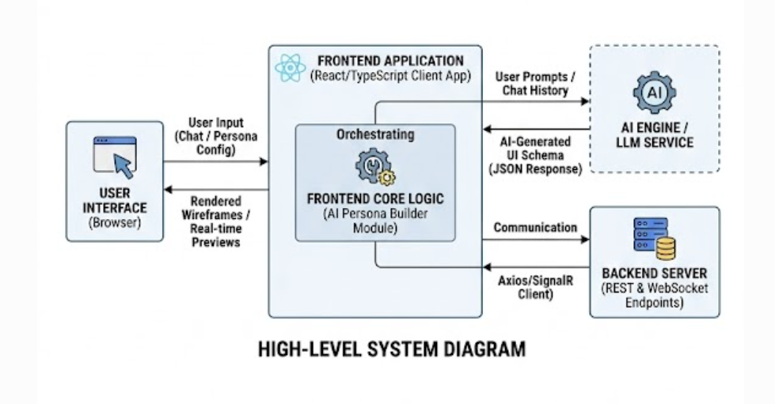
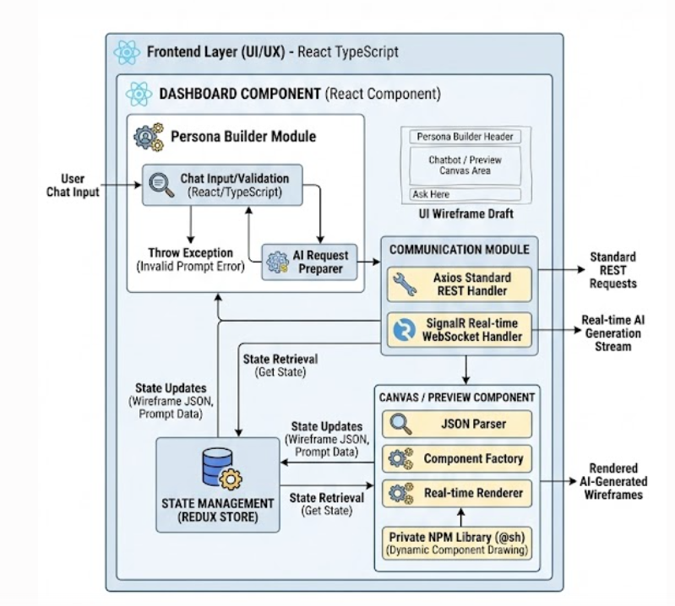
Detail level diagram
Architectural Breakdown
1. Core Core Components
- Dashboard Component (Persona Builder):
  - Built using React TypeScript.
  - Acts as the primary interface that houses the Persona Builder.
  - It takes chat input and attempts to generate a UI based on the customer's request.
  - Error Handling: If the user's prompt or request is invalid, it is designed to throw an exception.
- Canvas / Preview Component:
  - Responsible for taking the AI JSON response/output and dynamically drawing/rendering the wireframe components.
  - Utilizes a custom or specific npm library referenced as @sh.
2. Infrastructure & Data Flow
- State Management: Powered by Redux to handle setting and getting the application's state across components.
- Communication Layer: Dual-protocol setup depending on the data type:
  - Axios: Used for standard, traditional REST requests.
  - WebSockets (SignalR): Used specifically for streaming the AI wireframe generation in real-time to ensure a smooth, instantaneous user experience.

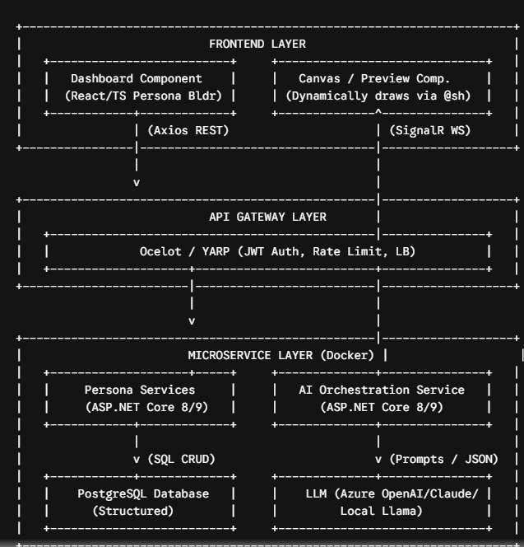
Component Flow Description
- Request Initiation: The user interacts with the React Dashboard. Standard operations hit the API Gateway via Axios, while the streaming wireframe generation connects over WebSockets (SignalR) bypassed or handled through the gateway.
- Gateway Routing: The Gateway applies JWT authentication and load balancing, routing traffic to the specific microservice.
- Data Operations: The Persona Service interacts with PostgreSQL to fetch or update custom configuration profiles.
- AI Generation: The AI Orchestration Service receives the persona structure, appends the system prompts, sends it to the target LLM (e.g., GPT-4o), and streams the structured UI JSON back down through the SignalR channel to the Canvas Component for real-time rendering.
Architectural Breakdown
2. API Gateway Layer
- Purpose: Acts as the single entry point for the frontend client, abstracting the underlying microservices architecture.
- Technologies Considered: Ocelot or YARP (Yet Another Reverse Proxy).
- Core Responsibilities:
  - Rate Limiting
  - Load Balancing
  - JWT Authentication (JWT Auth)
3. Microservice Layer (Backend)
- Base Architecture: Each microservice is built using ASP.NET Core 8.0 / 9.0 following Clean Architecture principles.
- Deployment: Containerized using Docker Containers.
A. Persona Services
- Responsibility: Manages the CRUD (Create, Read, Update, Delete) operations for customer personas.
- Database: PostgreSQL for storing structured data.
B. AI Orchestration Services
- Responsibility: Acts as the bridge between the core application logic and the Large Language Models (LLMs).
- Supported LLMs: Azure OpenAI (GPT-4o or Codex), Claude, or a local model (Llama).
- Core Logic / Workflow:
Component Flow Description
- Request Initiation: The user interacts with the React Dashboard. Standard operations hit the API Gateway via Axios, while the streaming wireframe generation connects over WebSockets (SignalR) bypassed or handled through the gateway.
- Gateway Routing: The Gateway applies JWT authentication and load balancing, routing traffic to the specific microservice.
- Data Operations: The Persona Service interacts with PostgreSQL to fetch or update custom configuration profiles.
- AI Generation: The AI Orchestration Service receives the persona structure, appends the system prompts, sends it to the target LLM (e.g., GPT-4o), and streams the structured UI JSON back down through the SignalR channel to the Canvas Component for real-time rendering.
[User Input / Prompt] ──> [AI Orchestration (Semantic Kernel/SignalR)] ──> [Structured JSON Output]
Step-by-Step Flow
- Input: The user creates a persona with a descriptive prompt.
  - Example provided: "hey AI pls create KYC Form Layout to onboard Bank new Customer in React UI."
- Processing: The orchestration layer processes the text and streams back structured JSON schemas representing specific UI layout schemas.
- Output JSON Structure: The notes outline the exact JSON fields expected from the generator to match your React component props:
- pageTitle: e.g., "ABC Bank"
- Layout: An array of UI block objects containing:
  - id: uniqueID
  - type: Component types such as "steptracker", "FormSection", or "outer box"
  - Props: Contains metadata like "section Header"
  - desc: Description attributes like "Tes Desc"
  - variant: Stylistic variations such as "default", "warn", "info", or "primary"
  - fields: Nesting arrays for individual input definitions within layout blocks

Technical Specifications Breakdown
1. LLM Orchestration & Real-time Communication
- Orchestration Framework: The system utilizes either the Microsoft Semantic Kernel SDK or LangChain.NET to handle prompting and LLM orchestration tasks.
- Token Streaming: Communication relies on SignalR to stream JSON tokens back to the user interface in real time. This specific choice is implemented to prevent application timeout issues during heavy generation phases.
2. Wireframe Service
- Core Responsibilities: This microservice is responsible for saving, versioning, and managing the dynamically generated wireframes.
- Database: It utilizes a NoSQL database like MongoDB to effectively store and represent the wireframe document trees.
PersonaWireframeApp/ # Root Solution Directory
│
├── PersonaWireframeApp.sln # Visual Studio Solution File
│
├── src/ # Backend Source Code Folder
│ │
│ ├── GatewayAPI.csproj # API Gateway Project (Ocelot/YARP)
│ │ ├── Program.cs # Gateway Bootstrapper & Middleware
│ │ └── appsetting.json # Gateway Configuration (Routes, Rate Limits)
│ │
│ └── Service.WireframeAI/ # AI Orchestration & Wireframe Microservice
│ ├── WireframeAI.csproj # .NET Core Web API Project File
│ ├── Program.cs # Service Entry Point & Dependency Injection
│ │
│ ├── Hubs/ # SignalR Real-Time Streaming Layer
│ │ └── WireframeHub.cs # WebSocket Hub for Streaming JSON Tokens
│ │
│ ├── Domain/ # Core Business Entities & Constants
│ │ └── WireframeContent.cs # Schema / State Domain Models
│ │
│ └── Features/ # Feature-Sliced Application Logic
│ └── GenerateWireframe/ # Vertical Slice for AI Generation
│ └── GenerateWireframeHandler.cs # Command/Query Orchestration Handler
│
└── ClientApp/ # Frontend React TypeScript Application (UI)
├── package.json # NPM Package Dependencies & Scripts
├── vite.config.ts # Vite Build Tool Configuration
└── src/ # Client App Source Code
├── App.tsx # Main Application Root Layout
└── main.tsx # DOM Injection & App Bootstrapping

